Name : sooriyamoorthy
register number: 23MIS0296

case study-1:
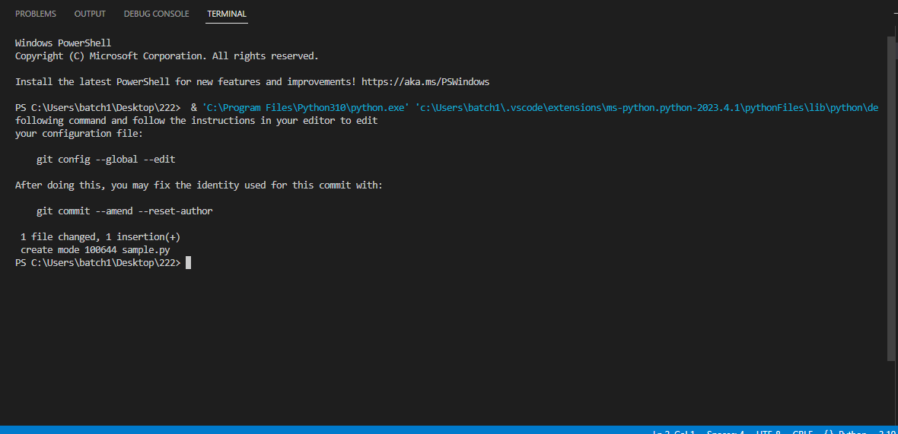

case study- 2:

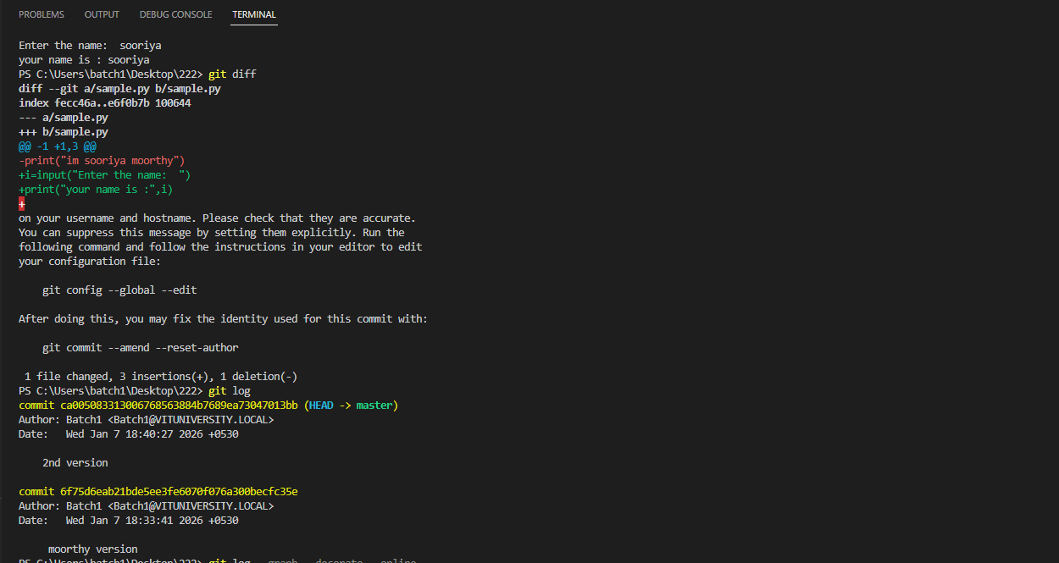

case study -3

